Dance I Study Guide
Jazz & Ballet Terminology

- Attitude- A pose in which one leg is raised in back or in front with knee bent, usually with one arm raised.
- Battement- A large kick
- Chaine- A two step turn, a chain of links
- Chasse- Step together step, used to travel (to chase)
- DEGAGE- To disengage the foot
- Isolation- Movement of one body part keeping the rest of the body still
- Pas de bouree- Done in either jazz or ballet- the jazz definition of the first step crosses behind the leg, the second step is quick and third is a lunge.
- Passe- A position of the legs where the foot on one leg touches the knee of the other and also to pass through. This may be either parallel or turned out.
- Pirouette- A complete turn of the body executed on one leg; the working leg is placed with the foot in posse.
- Plie- to bend
- Releve- To rise on your toes
- Spotting- The fixing of the eyes on one spot as long as possible during turns to avoid dizziness and to keep one's orientation.
- Tendu- To point or stretch
Positions of the Feet
(In Jazz, feet are positioned parallel. In Ballet, the feet are turned out. )
Jazz
- First Position: Feet together
- Second Position: Feet parallel, shoulder width apart
- Fourth Position: Often used to prep for a turn

1st Position 2nd Position 4th Position
Ballet
- FIRST POSITION: The balls of the feet are turned out completely. The heels touch each other and the feet face outward
- SECOND POSITION: The balls of both feet are turned out completely, with the heels separated by the length of one foot. Similar to first position, but the feet are spread apart
- THIRD POSITION: One foot is in front of the other with the of the front foot touching the middle of the back foot
- FOURTH POSITION: The feet are placed the same as third position, but one step apart.
- FIFTH POSITION: With both feet touching, the toes of each foot reaches the heel of the other

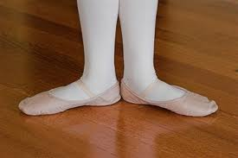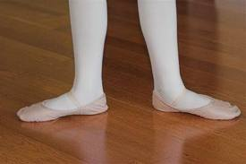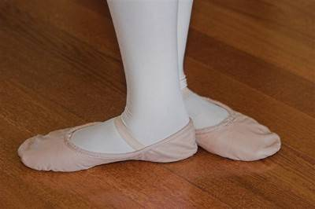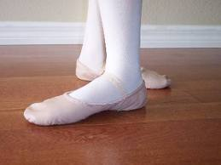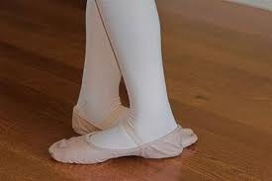
1st Position 2nd Position 3rd Position 4th Position 5th Position

Stage Directions

