Dance II Ballet & Jazz Terminology
- Avant- forward
- Bas- low
- Coupe- cut, cutting
- Dedans- inward
- Degage- to disengage
- Dehors- outward
- Derriere- behind, back
- Devant- in front
- En- in
- Fondu- sinking down
- Haut- high
- Plie- to bend
- Port de bras- Carriage of the arms
- Releve- to rise
- Rond de jambe- Round of the leg, that is, a circular movement of the leg
- Tendu- to point & stretch

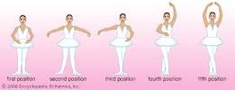
First Second Third Fourth Fifth

