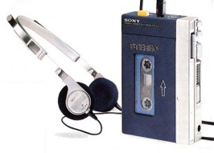
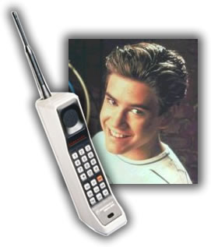
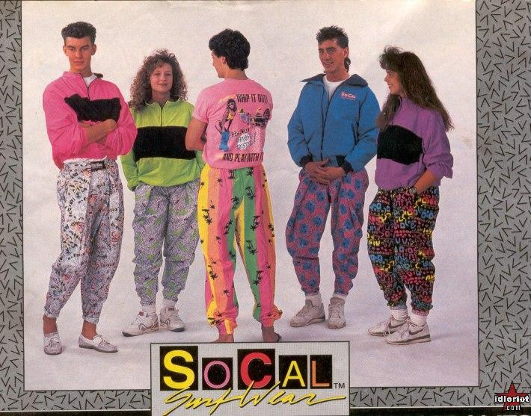
Dance of the Decades

1990-1999

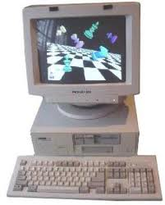
The 1990s was truly the electronic age. The World Wide Web was born in 1992, changing the way we communicate (email), spend our money (online gambling, stores), and do business (e-commerce). By 1994, 3 million people were online. And by 1998, this figure increased to 100 million people. It is estimated that by 2001, some 1 billion people will be connected. Internet lingo like plug-ins, BTW (by the way), GOK (God only knows), IMHO (in my humble opinion), FAQS, SPAM, FTP, ISP, and phrases like "See you online" or "The server's down" or "Bill Gates" became part of our everyday vocabulary. We signed our mail with a :-) smile, a ;-) wink, or a :-* kiss. And - everyone has a cell phone. There were more music choices available than ever, although radio stations tended to find a niche and stick to it rather than playing a mix. Latino music grew in popularity. Country became more mainstream, and Grunge and Gansta appeared. In the 1990’s there was a rise in the popularity of line dancing especially in the form of country western dancing. Boot Scoot Boogie and Achy Breaky Heart were two signature line dances. The Electric Slide and its many variations were a development of the 1970’s Bus Stop.
