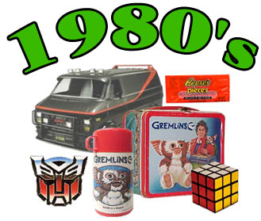
Dance of the Decades

1980-1989

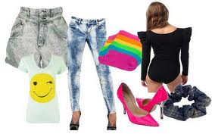
The 1980s became the Me! Me! Me! generation of status seekers. During the 1980s, hostile takeovers, leveraged buyouts, and mega-mergers spawned a new breed of billionaire. Forbes' list of 400 richest people became more important than its 500 largest companies. Binge buying and credit became a way of life and 'Shop Til you Drop' was the watchword. Video games, aerobics, minivans, camcorders, and talk shows became part of our lives. The Flashdance look had young and old in tank tops, tight-fitting pants or torn jeans, and leg-warmers. Teens not wearing designer clothes opted for Michael Jackson's glove or Madonna's fishnet stockings, leather, and chains. Cable was born and MTV, originally intended to be promos for albums, had an enormous impact on music and young people. The 1980’s were characterized by street dancing in the form of break dancing and the emergence of pop star Michael Jackson. The moonwalk and the robot were just a few moves he made popular. The digital compact disc (cd) revolutionized the music industry. Dances learned on MTV included slam dancing, lombada, and break dancing. Harlem's gay Black and Latino males imitated the beautiful jet set with their (then underground) Vogueing, a 'pose' dance popularized by Madonna incorporating the struts and stances of high fashion models. Pop, rock, new wave, punk, country, and especially rap or hip hop became popular in the 80s. Rap was new in the late 80s and 90s. It had started in prison 20 years earlier by jailed black inmates who, in the absence of instruments, turned poetic meter into musical rhythm. The early rap heard on ghetto streets was abrasive and laced with hostility toward society. Early important groups are Milli Vanilli, M. C. Hammer (great site, but it takes time), Vanilla Ice, and L.L. Cool J. At the turn of the decade, many were happy to leave the spendthrift 80s for the 90s, although some thought of the eighties as TOTALLY Awesome.

