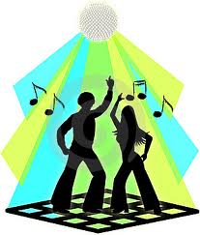
Dance of the Decades

1970-1979

The chaotic events of the 60's, including war and social change, seemed destined to continue in the 70's. Major trends included a growing disillusionment of government, advances in civil rights, increased influence of the women's movement, a heightened concern for the environment, and increased space exploration. Many of the "radical" ideas of the 60's gained wider acceptance in the new decade, and were mainstreamed into American life and culture. Amid war, social realignment and presidential impeachment proceedings, American culture flourished. Indeed, the events of the times were reflected in and became the inspiration for much of the music, literature, entertainment, and even fashion of the decade. By the 1970's, the term "rock & roll" had become nearly meaningless. This decade saw the breakup of the Beatles and the death of Elvis Presley, robbing rock of two major influences. Pop music splintered into a multitude of styles: soft-rock, hard rock, country rock, folk rock, punk rock, shock rock - and the dance craze of the decade, disco! In the 1970’s Disco-mania revolutionized the music recording industry. Traditionally radio decided which music would be introduced to their listeners. With the advent of disco comes a new sequence of events in determining a hit song. In the 70’s recording market the disco club often receives the first copy of a new song. Thus a song could become popular before it was on the radio. Dance clubs now controlled popularity of a song over DJ’s on the radio. Dances popular in the 70’s were the Bus Stop, Night Fever and the Latin Hustle.

