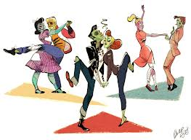
Dance of the Decades

1960-1969

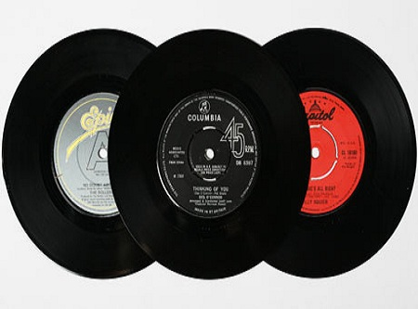
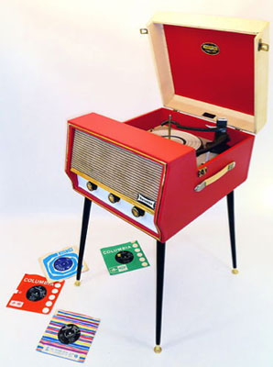
The sixties were the age of youth, as 70 million children from the post-war baby boom became teenagers and young adults. The movement away from the conservative fifties continued and eventually resulted in revolutionary ways of thinking and real change in the cultural fabric of American life. No longer content to be images of the generation ahead of them, young people wanted change. The changes affected education, values, lifestyles, laws, and entertainment. Many of the revolutionary ideas which began in the sixties are continuing to evolve today. In 1960, Elvis returned to the music scene from the US Army. America, however, was ready for a change. The Tamla Motown Record Company came on the scene, specializing in black rhythm and blues, aided in the emergence of female groups such as Gladys Knight and the Pips, Martha and the Vandellas, the Supremes, and Aretha Franklin, as well as some black men, including Smoky Robinson, James Brown, Jimi Hendrix, and the Temptations. Bob Dylan helped bring about a folk music revival, along with Joan Baez and Peter, Paul & Mary. The Beach Boys began recording music that appealed to high schoolers. The Beatles, from England, burst into popularity with innovative rock music that appealed to all ages. The Righteous Brothers were a popular white duo who used African American styling to create a distinctive sound. There was a major change in popular music. Radio continued to be the primary means of listening to music. The major development was a change from primarily AM to FM . Radio was supplemented by American Bandstand, watched by teens from coast to coast. They not only learned the latest music, but how to dance to it. When Chubby Checker introduced the twist on the show in 1961, a new craze was born, and dancing became an individual activity. The Mashed Potato, the Swim, the Watusi, the Monkey and the Jerk followed the Twist, mimicking their namesakes. Each new dance often lasted for just a song or two before the next one came along. Eventually the names and stylized mimicry ceased and the dancers just moved however they wanted. For those who preferred watching the dancers, Go-go girls, on stages or in bird cages, danced above the crowd. Many movements of the 1960’s reflected the discontent felt by many Americans because of civil rights issues and its involvement in the Vietnam War. Movement used in social dances became more grounded and used a lot of closed fists gestures. Individualism was evident. The signature event of the 60’s was Woodstock- a three day event of music, peace, drugs, rock n’ roll and a clear
display of anti-establishment.

